Chapter 7, Problem 75.

In the circuit of Fig. 7.140, find v_{o} and i_{o}, given that v_{s} = 4 u(t) V and v(0) = 1 V.
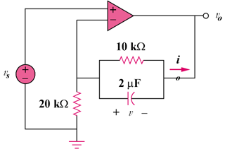

Figure 7.140
For Prob. 7.75.

